Java

Java : - High level programming language and platform.

Why Level programming language

User friendly and can we run any platform.

Where we can: -

1. Desktop Applications: VLC Player
2. Web Applications: - LinkedIn, Snapdeal
3. Enterprise Applications: - Banking System
4. Robotics
5. Games

Features: -

1. Simple: - easy to learn, its syntax is simple
2. Secured:
3. Object Oriented
4. Portable
5. Platform Independent

* How to set the path in Java: -

Tools : -

1. Eclipse
2. STS
3. IntelliJ

🡺 How to Create Project: -

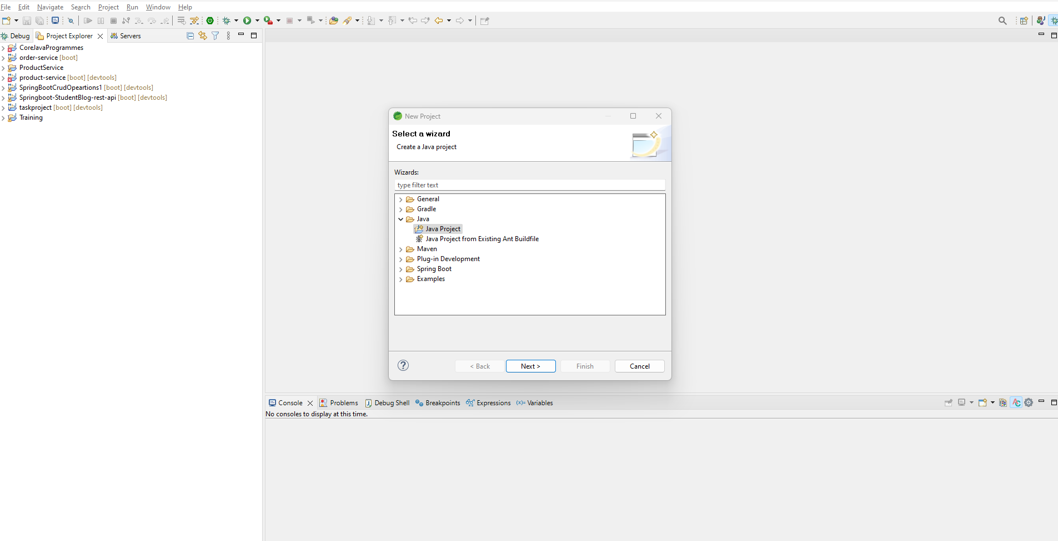

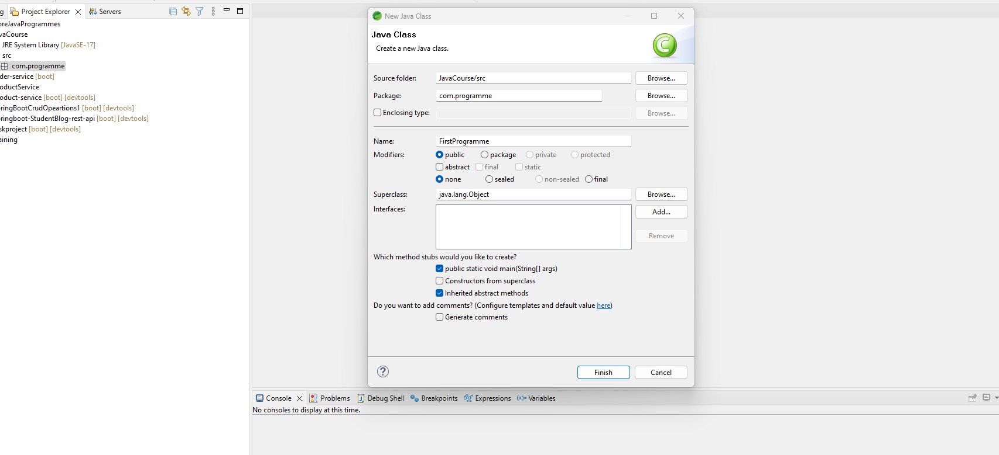

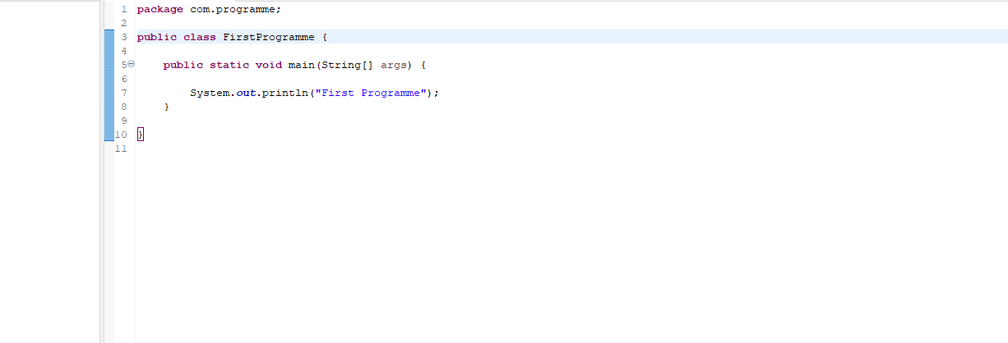

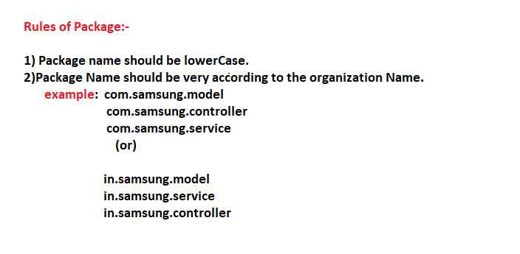

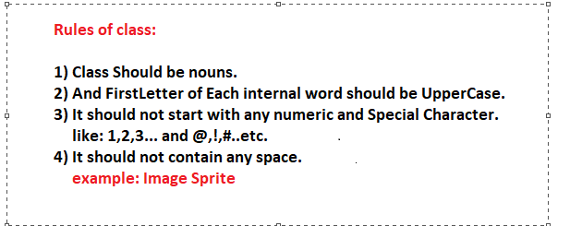

Difference b/w class and method: -

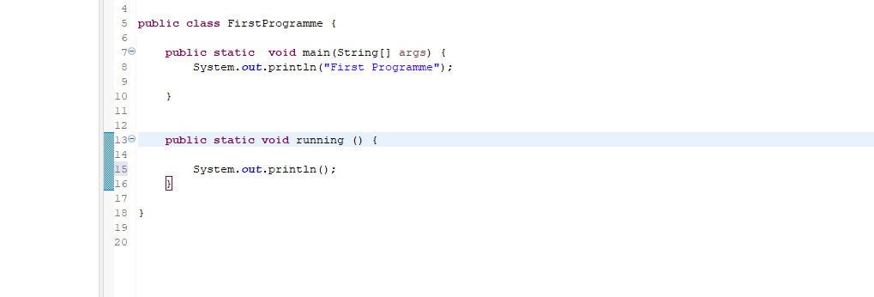

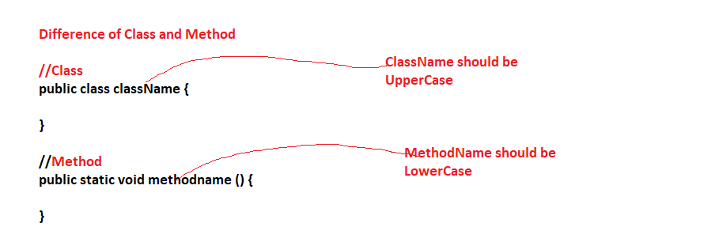

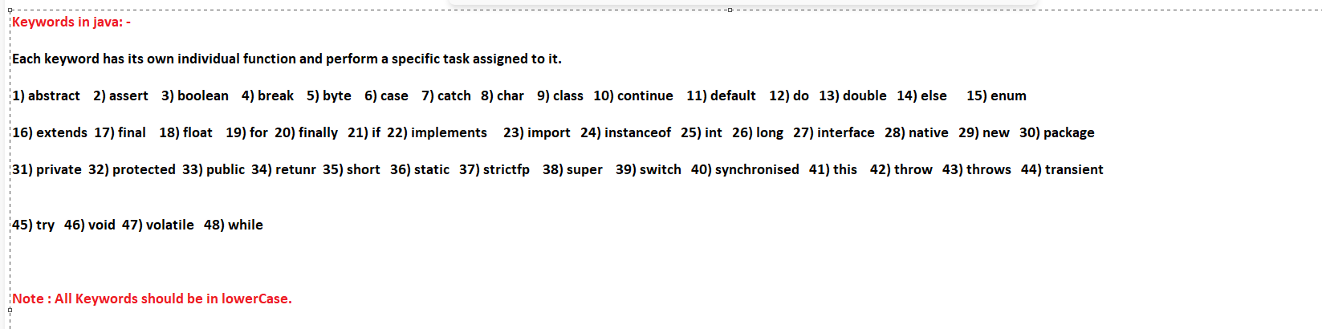

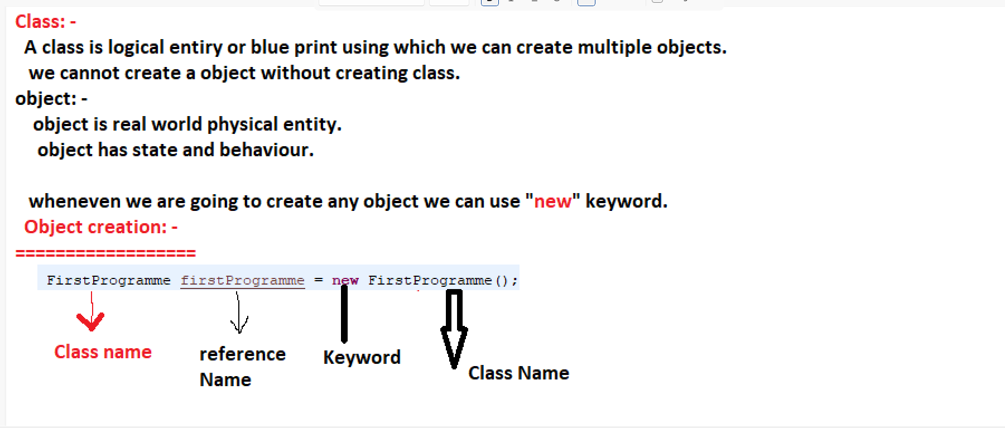

Example: -

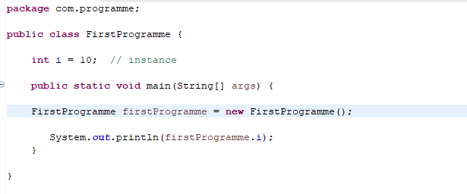

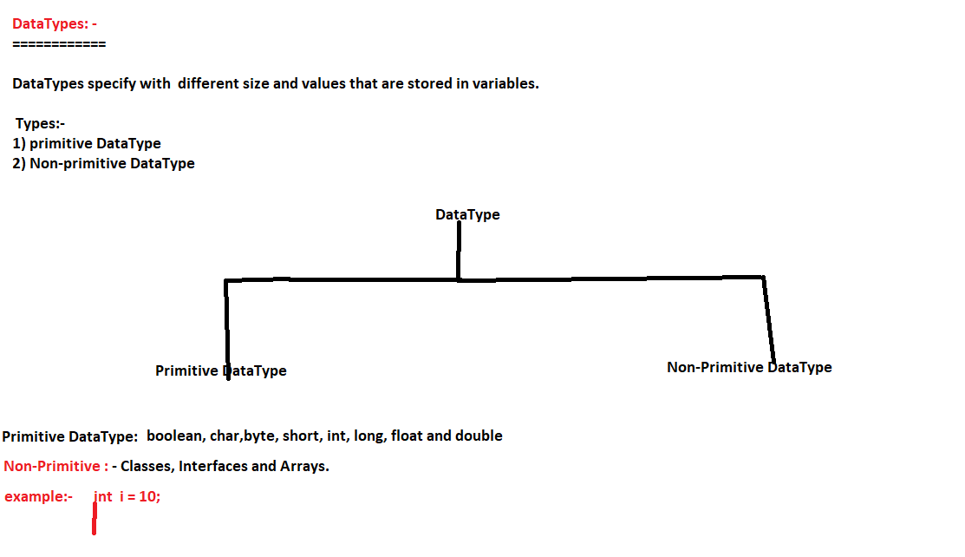

Example : -

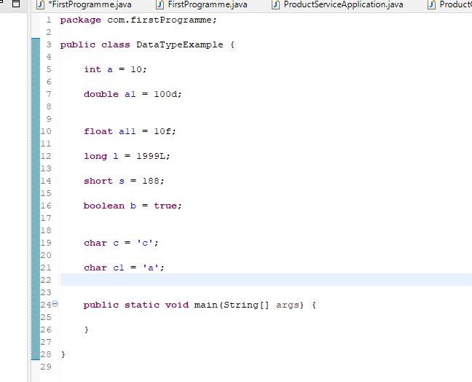

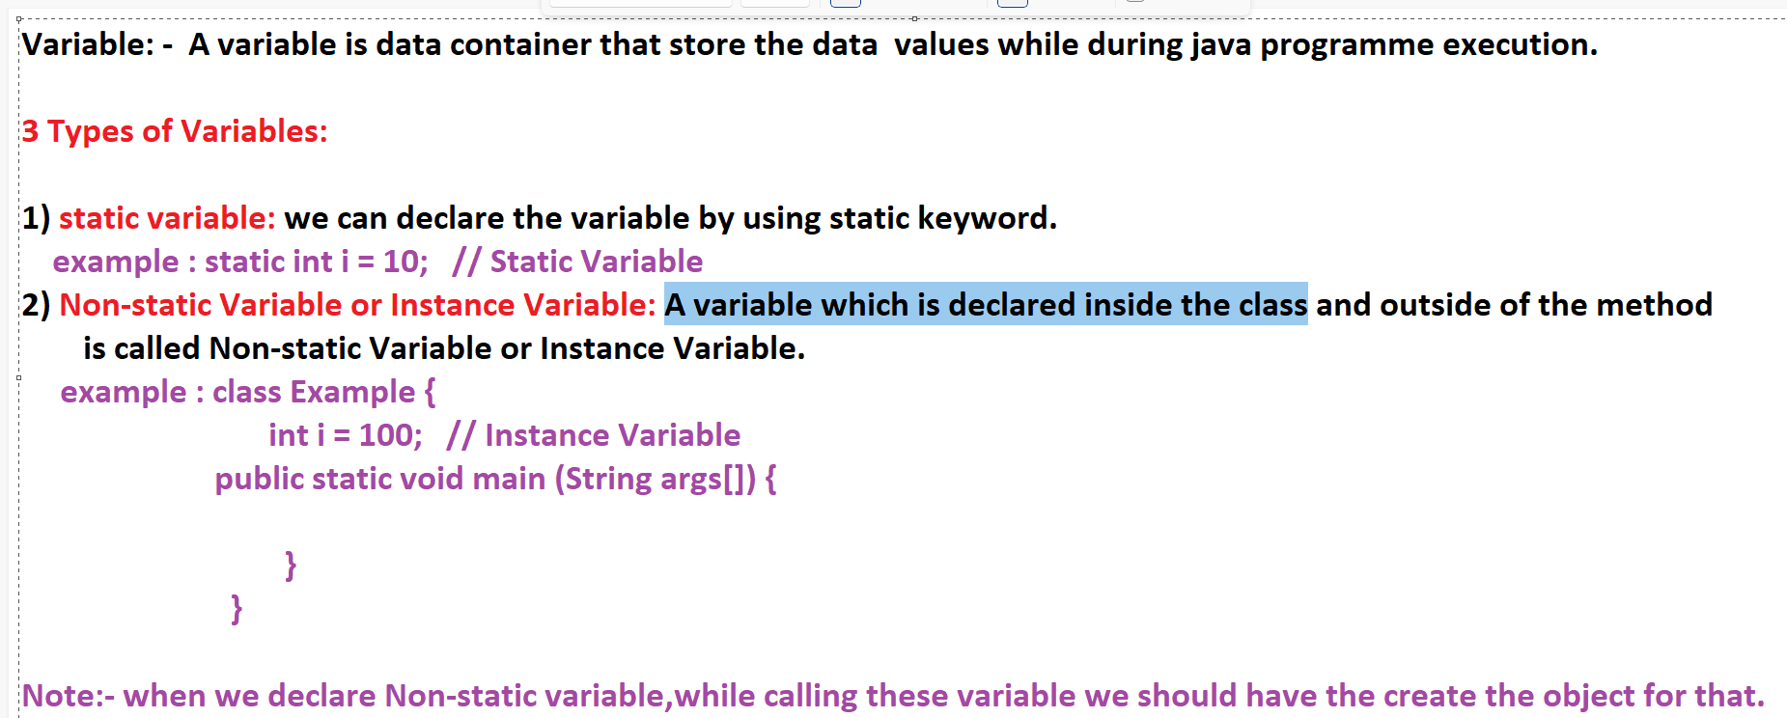

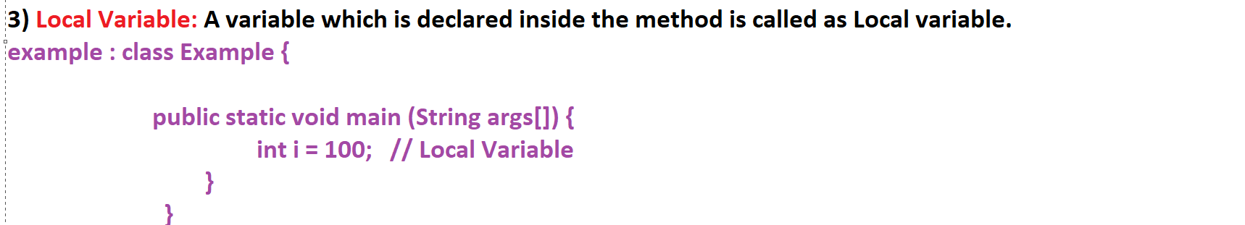

Example: -

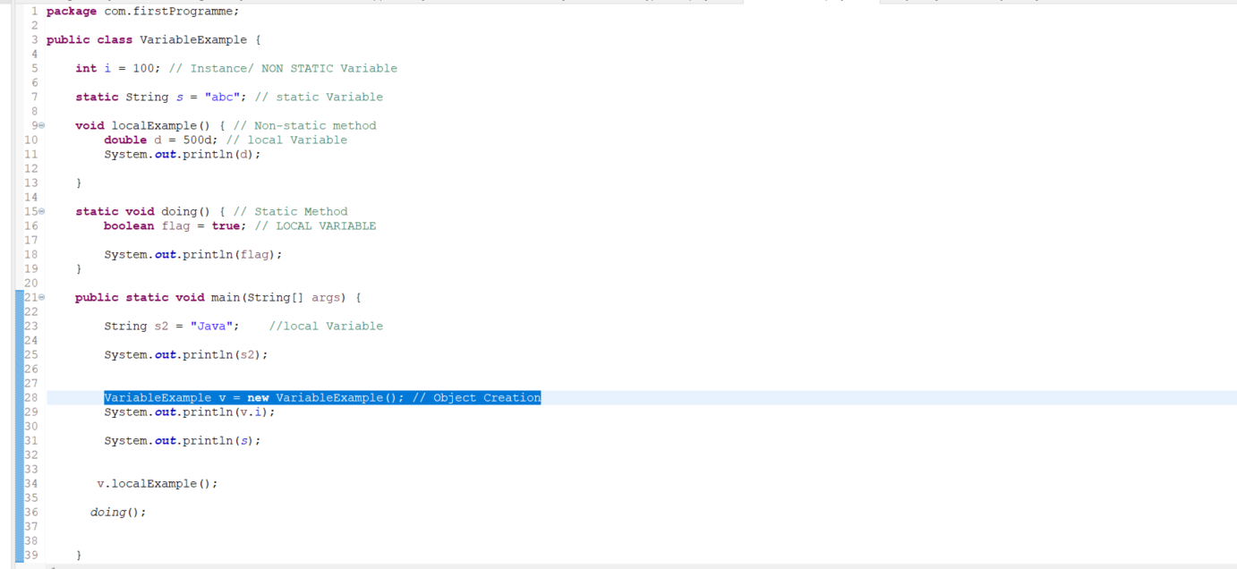

Operators:

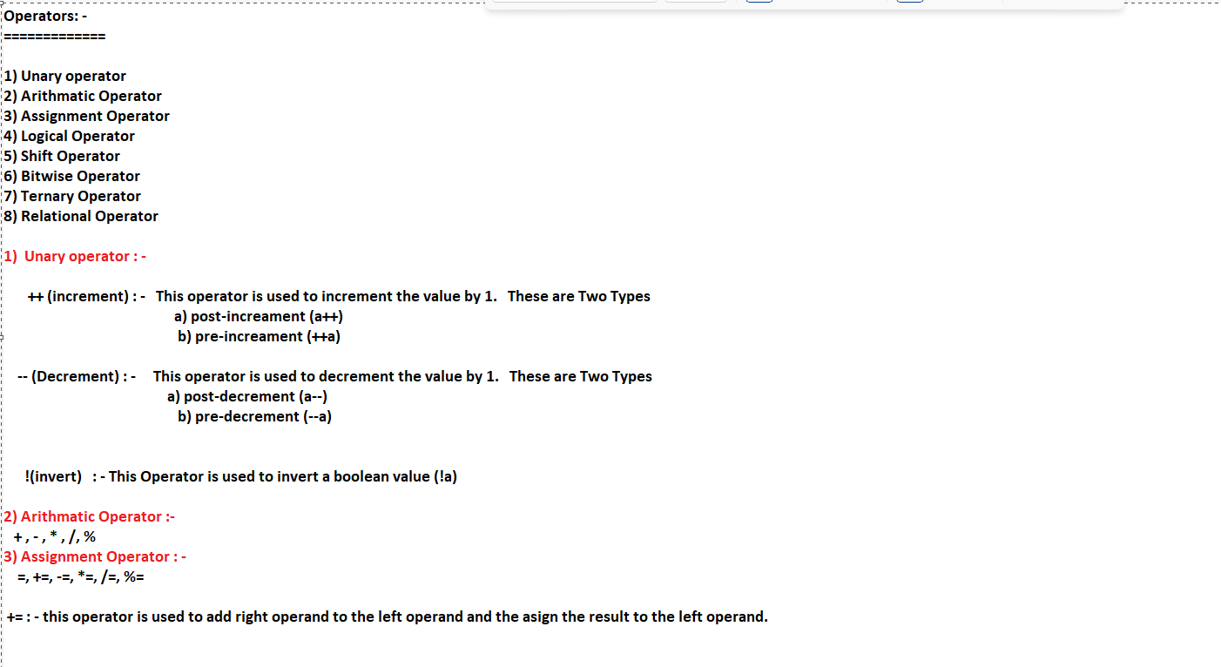

Iterative Statements: -

For Loop: -

=========

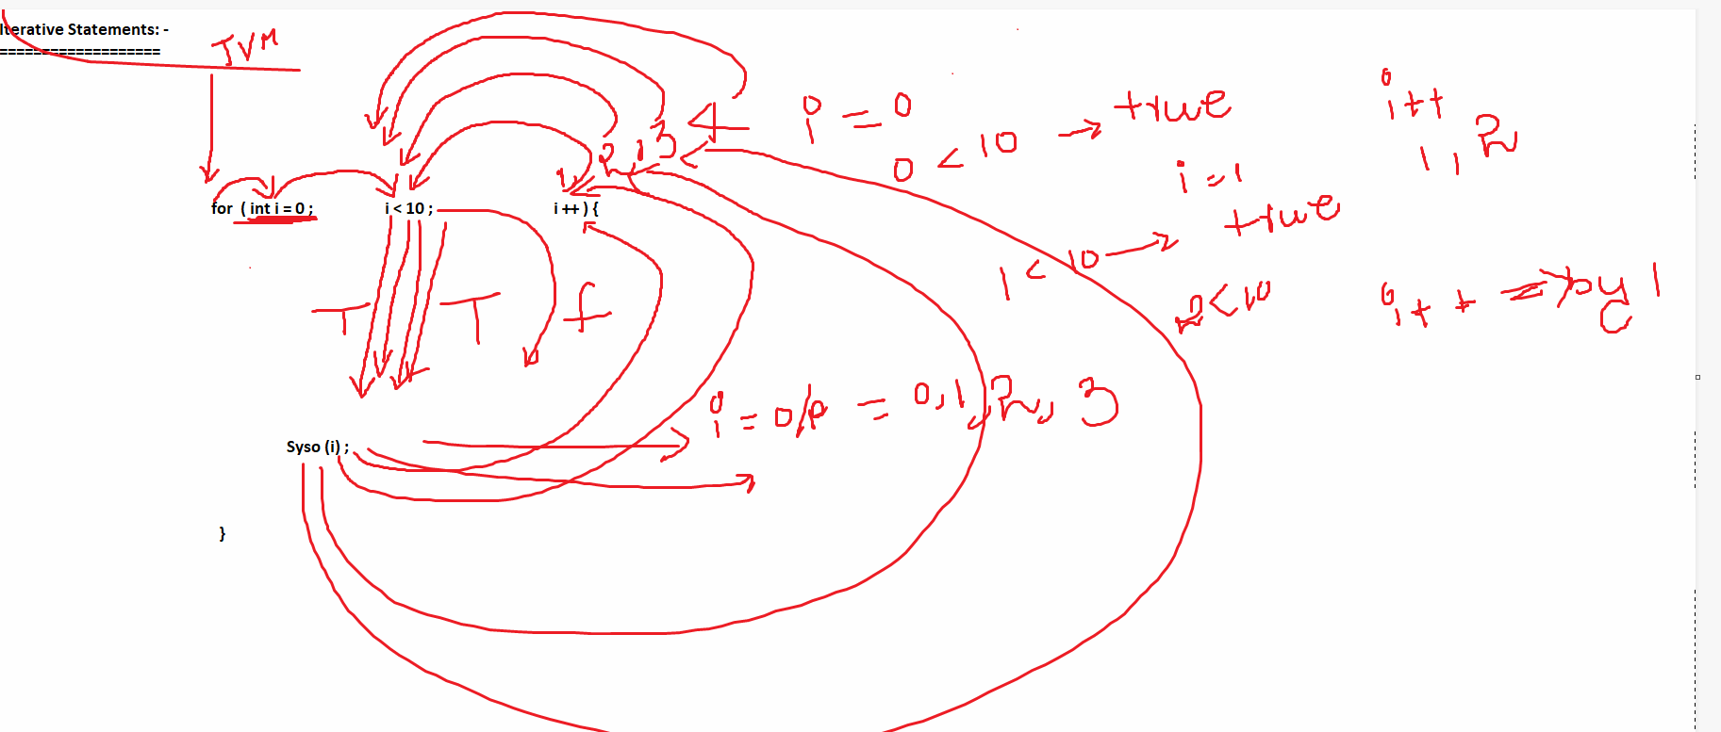

Iterative Statements: -

============================

for , while and do while

for Loop : -

==============

Syntax :

for (expr1 ; expr2 ; expr3) {

---------------------

-----------------------

-------------------------

}

example : for (int i = 0 ; i < 10; i++) {

System.out.println(i);

}

Expr1 : for ( int i= 0,float f =0.0f; i < 10, f < 10.0f; i++,f++ ) {

}

Exp 2 : Condition ==> always it will excuted True

Expr3 :

for (int i = 0; i < 10 ; System.out.println("hello")) {

System.out.println(i);

i = i + 1;

}

where we can use : -

==============================

In java applications, if we know the numbers if iterations over the loop of the body in advance before writing loop there we have to use "for" loop.

Example : int [] a = {1,2,3,4,5,6};

size = a.length() ; starting index for array is 0, and index ending is 4.

DrawBacks : -

==========

1) we must declare a separate variable for looping purpose.

2) At each and every iteration, we must execute the Conditional expression.

3) At each and every iteration, we must perform the loop variable increment/ decrement Operations.

4) In above approach, we are able to get array elements by providing index value explicitly, in this case, they may be chance for getting the ArrayOutOfBound of Exception.

for-each loop: -

==============

int [] a = {1,2,3,4,5,6};

Syntax : -

==============

for (Array_DataType var_name : Array_Ref_var) {

Syso(a);

}

Example : for (int v1 : a ) {

System.out.println(v1);

}

====================================================

when we can Use these means :

for Each is applicable for retrieving elements from arrays & from collections only.

it is not applicable for normal Iterations over the code.

================================================================================================================================

While Loop :

====================

Syntax : while (condition) {

------------------------

------------------------------------

}

example : int i = 0;

while (i < 10 ) {

System.out.println(i);

i = i + 1;

}

Do while loop:

=====================

Syntax : -

do {

-----------------

----------------

------------------

} while (condtion);

======================================================================================================================

Transfer Statements: -

===========================

break, continue and return